**Pipe and Redirection Operators_Assignments**

1. To create a script named “myscript” in current directory “vi myscript.sh” is used.



* 1. To create a dir named “subd1” in current directory “mkdir subd1” is used.



* 1. To create a file named dircontent with contents of the current directory “ls > dircontent” command is used.



* 1. To display the contents of the file dircontent the command “cat dircontent” is used.

* 1. To display the contents of a non existing file named unknownfile , the command used is “cat unknownfile”.



1. To run the script and validate the output in following cases
   1. To redirect only the stdout to an o/p file named stdout.txt, the command used is “./myscript.sh > stdout.txt”



* 1. To redirect only the stderr to an o/p file named stderr.txt, the command used is “./myscript.sh 2> stderr.txt”

* 1. To redirect both stdout and stderr to an o/p file named stdall.txt, the command used is “./myscript.sh > stdall.txt 2>&1”



* 1. To display all o/p and error and also redirect both stdout and stderr to an o/p file named stdall.txt, the command “./myscript.sh | tee stdall.txt” is used.

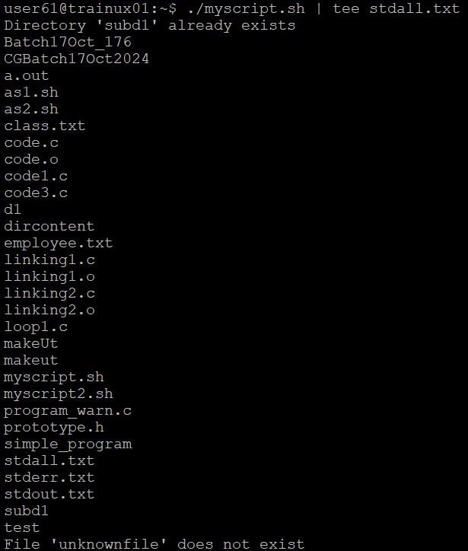

1. To redirect the output of command below using pipe (|) to wc and get the output, we use the command “ls -l | wc”

